- SYSTEM AND APPLICATIONS DEFINITIONS
Cerberus manages Systems and Applications. A system is composed of various applications. You can select your System using the drop-down list on the top right corner
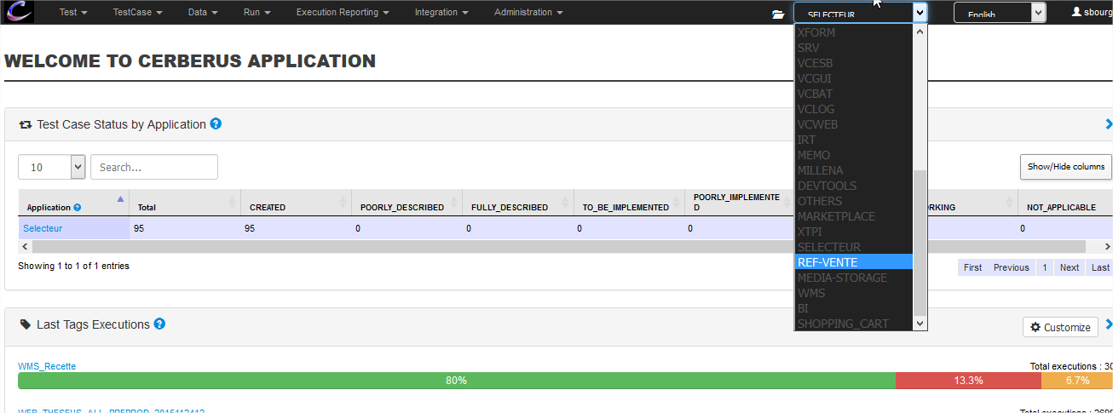
Then, you can figure out applications composing your system using the menu ‘Integration > Application’
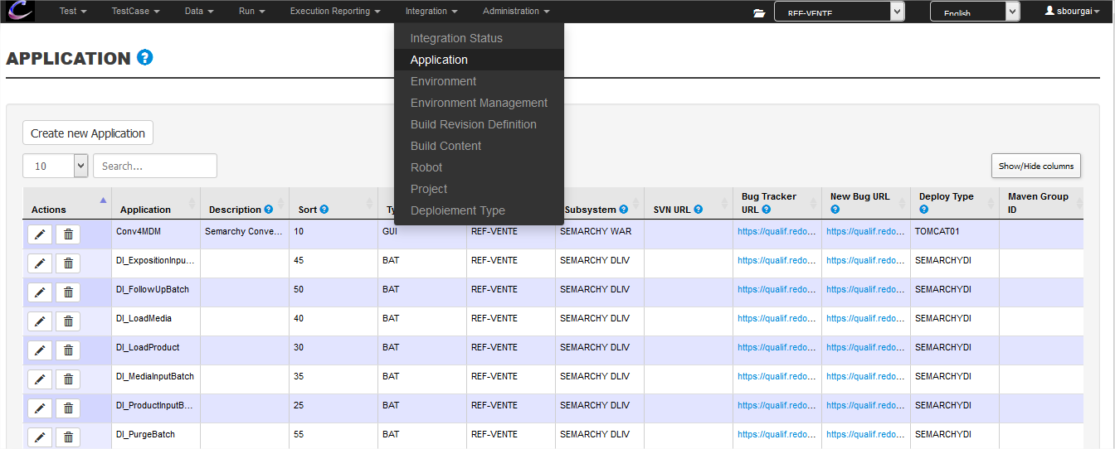
- MANAGE VERSIONS
Cerberus does not manage application versions. It only manages system versions. You can manage system versions in two steps :
- Define the version of your system
- Set which level of your applications is composing your system version

  - Define the version of your System
You can define the version of your system using the menu “INTEGRATION >> BUILD REVISION DEFINITION”
Every commits of your applications will pop here. If you have a non-commitable application, you can create a version of this application using the “create new build content” button
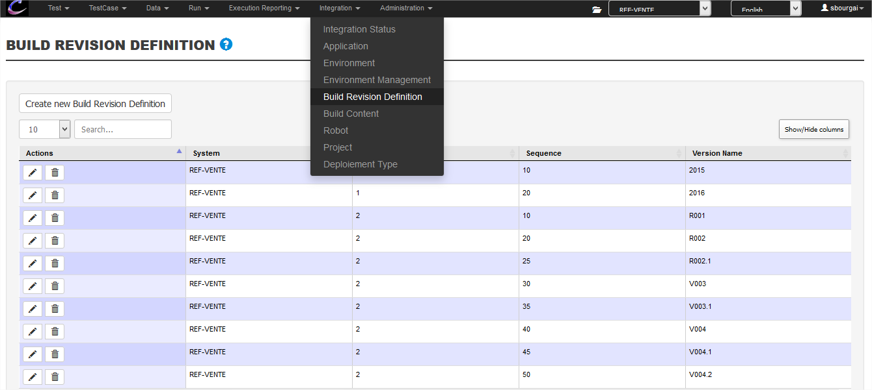
There is no restriction for “Version Name”. This version is defined with following various “levels”. Levels are ordered using “sequence”
Ex :
- Level 1, sequence 10 => 2015
  - Level 2, sequence 10 => R001
  - Level 2, sequence 20 => R002
  - Level 2, sequence 25 => R002.1
  - Level 2, sequence 30 => V003
- Level 1, sequence 20 => 2016
So a version of you system is identified this way :
- <level 1>.<level 2>
- Ex: My system version is 2015.V003

  - Set which level of your applications is composing your system version
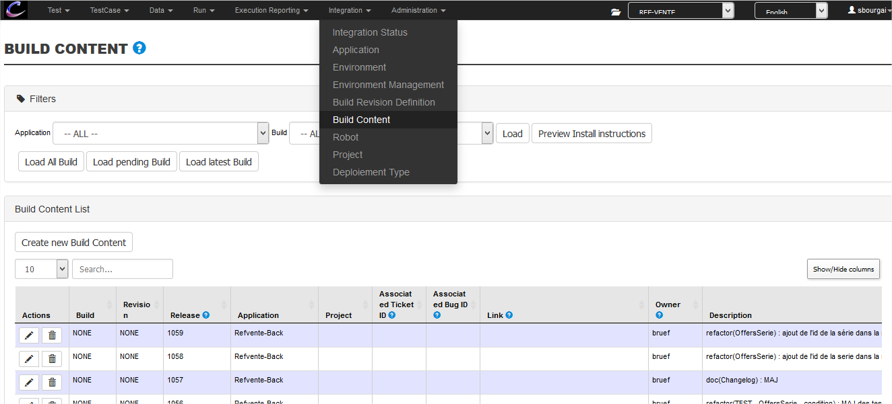

Level 1 of your system is known as Build
Level 2 of your system is known as Revision
TIP: the maven version kown by the developer is shown on the very right column
Here, the DI_LoadProduct will be included in the version 2015.V004.2 of the system
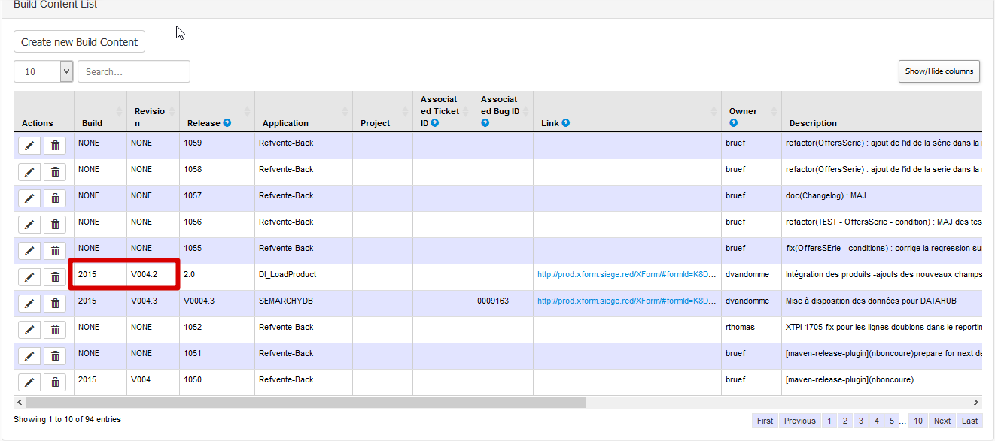
For every application you can set which the Build and Revision of the sytem it is a part of.
Finally, you can figure out what is included in a build,revision of your system clicking on the “preview install instructions” button

